Project Design Phase
Problem – Solution Fit Template

Date | 15 February 2025
Team ID | LTVIP2025TMID32756
Project Name | Pollen’s Profiling:Automated Classification Of Pollen Grains
Maximum Marks | 2 Marks

Problem – Solution Fit Template:
The Problem–Solution Fit means identifying a real and relevant problem faced by your target users and ensuring your proposed solution effectively addresses that problem. This template helps in mapping out user needs, constraints, existing alternatives, and defining how your solution creates meaningful improvements.
Purpose:
✅Solve complex problems in pollen identification by automating classification using AI and image processing.
✅ Reduce time and human error by replacing manual microscopic methods with accurate automated systems.
✅ Increase adoption of digital tools in palynology and environmental research by integrating accessible and efficient solutions.
✅ Enhance communication and research collaboration by providing standardized and shareable pollen data.
✅ Support large-scale ecological and agricultural studies with faster, more reliable pollen data analysis.
✅ Understand the current manual workflow to improve accuracy, consistency, and scalability in pollen grain classification.
Template:
Customer (Red Zone)
Customer Segments – Botanists, palynologists, agri-researchers
Customer Constraints – Time-consuming, expert-dependent, manual
Available Solutions – Microscopic analysis, outdated tools
Problem Space (Orange Zone)
Jobs to Be Done – Classify pollen faster and accurately
Problem Root Cause – Manual processes and inconsistency
Behavior – Long hours on microscopy, error-prone
Solution Space (Green Zone)
Triggers – Need for automation, big data in ecology
Your Solution – AI-based image classifier for pollen
Change in Behavior – More productivity and accuracy
Emotions Before/After – Frustrated → Confident
Usage – Used in research labs, web-based app
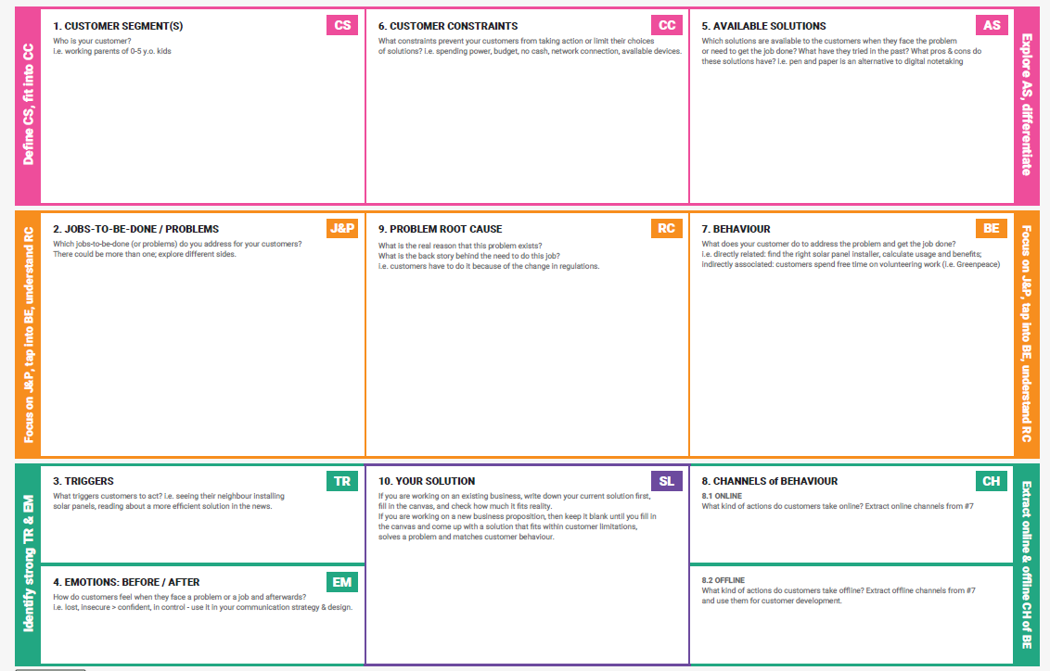
References:
- https://www.ideahackers.network/problem-solution-fit-canvas/
- https://medium.com/@epicantus/problem-solution-fit-canvas-aa3dd59cb4fe

